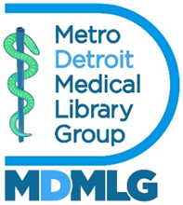
Metropolitan Detroit Medical Library Group
Annual Summer Meeting
Outreach Officer Report
June 17, 2026

In November 2025, the Executive Board reviewed four applications to the MDMLG Margaret Danowski Student Scholarship Award, and selected Wayne State University student Emily Minott as the 2025-2026 award winner. Emily received a $350 check and will be invited to join us at our Annual Summer Luncheon and Meeting.
Emily Minott has also agreed to be the MDMLG Student Representative, and will help with MDMLG outreach to library students.
I emailed the General Membership listserv asking if anyone has published in a journal in 2025. I received a few responses. These were shared in MDMLG News.
In January 2026, the Executive Board approved a $150 donation to the Detroit Literacy Coalition fundraiser, covering the cost of registration for two participants in the basketball clinic/health literacy event. I provided health literacy brochures with information on online resources for healthcare management. The camp was considered a success and will become an annual event. For more on the event, visit the recent issue of MDMLG News or the Detroit Literacy Coalition website.
The job bank was updated regularly.
Submitted by,
Steven Moore, Outreach Officer

